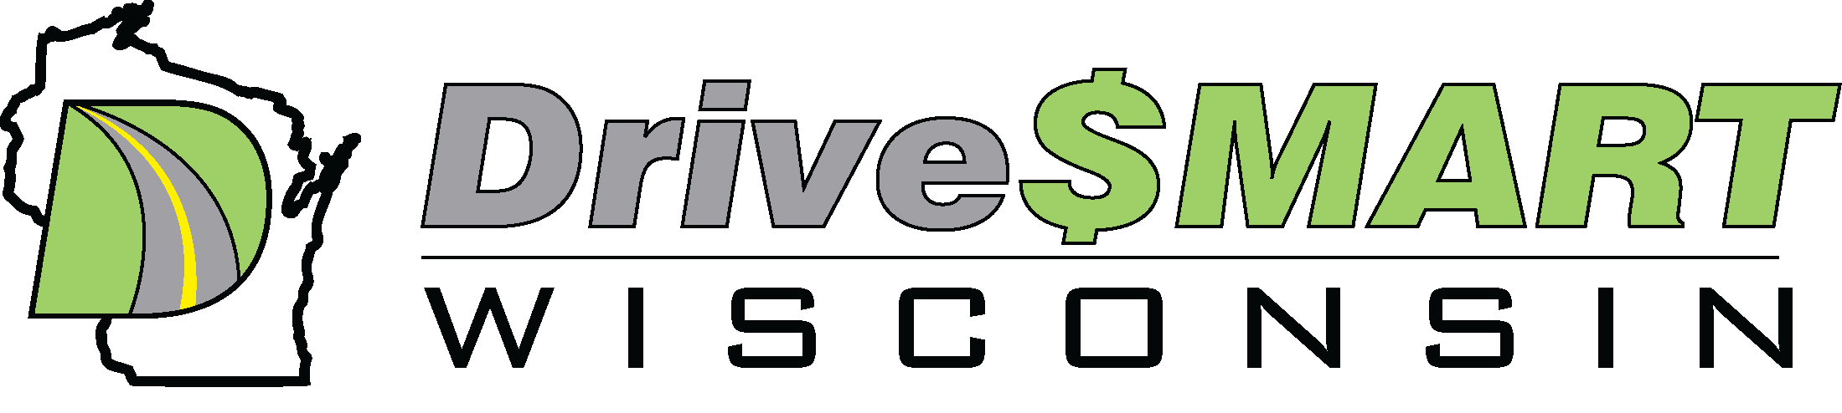
Media Alert: March 13, 2023
Contact: Bradlee Fons, Drive $mart Wisconsin, brad@drivesmartwi.com 414-881-4226
Website: https://drivesmartwi.com/
Do you want to save gas right now or are you thinking about an electric vehicle, or both?
D$W will talk on how to save up to 1.00 off the price of gas and EV’s at the Beloit Library.
WHAT:
With gas prices still high and fluctuating, drivers are looking for ways to lower those gas prices, and some be looking into EV ownership. Drive $mart Wisconsin, America’s largest and longest running fuel-efficient driving group, will present two free seminars at the Beloit Public Library on Saturday April 1st from 1 to 4pm that will address both of those issues. Bradlee Fons, co-founder of D$W and recognized fuel-efficient driving expert, will offer both seminars and will have members of D$W on hand for additional dialogue and support.
In the first seminar, “How to Save Gas 101”, drivers will learn about vehicle $mart Eco-driving skills that can increase their mileage with their current gas vehicles, lower tailpipe emissions, and become a safer driver, all at the same time. Typical mileage improvement can be from 10-30% with gas savings starting immediately.
In the second seminar, “Electric Vehicles 101”, D$W member and EV expert Ben Nelson, will offer attendees the chance to learn about the basics of EV’s, the various types of electric vehicles including Hybrid (HEV), Plug-In (PHEV) and full Electric (BEV), the basics of home/public charging and the real cost of EV ownership. D$W members will be on hand to give first person input on their personal EV experiences and performance expectations.
Since 2006, D$W has trained thousands of drivers on $mart Eco-driving skills, including the City of Milwaukee, Veolia Water, and Milwaukee Metropolitan Sewage District. These same $mart Eco-driving skills have been integrated into the Milwaukee Public Schools, MPS Drive instruction program, the first public school fuel-efficient drivers’ education program in the nation. The D$W $mart Eco-driving curriculum has been developed over the years, based on skills from the 1930-1940’s fuel economy runs, and the 1976 Dept of Energy DECAT program, and the Eco-Driving skills from Europe and Canada and infused with skills learned over the last several years from Guiness World Record Runs.
D$W also promotes all forms of clean automotive technology including alternative fuel and electric vehicles. D$W believes that the most powerful computer ever created is behind the wheel in every vehicle, it’s called the HU factor, also known as the driver. The driver and the drivers $mart skills are the true source of what D$W believes is the Fuel of the Future…Efficiency.
WHEN: Saturday, April 1 from 1pm to 4pm
WHERE: Beloit Public Library: 605 Eclipse Boulevard, Beloit WI. 53511
VISUALS: Handouts and displays will be available on fuel saving $mart Eco-driving and Electric Vehicles
WHO: Bradlee Fons and members of Drive $mart Wisconsin
####

