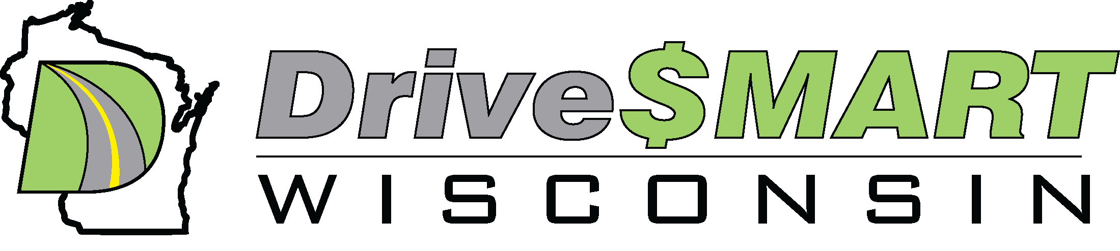
Release Date – Tuesday March 28, 2023
Contact: Bradlee Fons, Drive $mart Wisconsin, bjfons@drivesmartwi.com 414-881-4226
Interested in Saving Gas Right Now or Considering an EV?
D$W will Host Meet and a Drive Electric Earth Day Fair in Greenfield

WHAT: EV owners and enthusiasts from around the Midwest will display their electric vehicles and will hold an EV Owners Forum to highlight the clean-air benefits and cost-savings of electric cars on Saturday April 15 at the Greenfield Public Library from 10am to 2pm. In addition, there will be the 62nd D$W Meet will be held, where $mart Eco-Driving is promoted to achieve 10-30% or more fuel savings, lowering tailpipe emissions, extending range all while becoming a safer driver too.
In addition, Molly Collins, the Advocacy Director for the Lung Association Of Wisconsin, will give a presentation on the Wisconsin State of the Air 2022. Molly will address the need to encourage clean transportation policy to promote cleaner air and better health for all living in Wisconsin.
The free EV event is part of the annual nationwide Drive Electric Earth Day and this Drive $mart Wisconsin event is one of more than 162 DEED events across the country and will be the largest, most diverse, gathering of electric vehicles in SE Wisconsin this year.
Around Noon, there will be a D$W EV Owners Forum where EV owners will talk about their experiences and answer any and all questions on EV/PHEV ownership such as:
- the basics of electric vehicles including technology, safety, performance and benefits
- review the financial and environmental advantages including tax incentives
- discuss Drive $mart tips to optimize performance and extending driving range
WHEN: Saturday, April 15, 2023, 9am to 3pm
WHERE: Greenfield Public Library, 5310 West Layton Avenue, Greenfield Wi. 53220
VISUALS: There will be over at least 12 electric vehicles on display with owners offering free ride-and-drives. .
WHO: Members and EV Owners of Drive $mart Wisconsin and Molly Collins of Lung Association of Wisconsin

A complete list of National Drive Electric Earth Day events: https://driveelectricearthday.org/attend
For more about this Greenfield DEED: https://driveelectricearthday.org/event?eventid=3599




